**Meeting: Nov 13, 2019 (1:00 pm)**

* Based on the action plans from last meeting, things have been done in the simulation are:
  + Create figures based on cell-type and batch
  + Cluster analysis (with R package Seurat)
    - With help from Michelle
  + Proportions of zeros (Prof. Li explained that in the real data, it is common to have 90% of zeros in the count matrix. In the simulation, the matrices I generated have about 50% of zeros, which is OK.)
  + Fronius norm to quantify differences between corrected count matrices
  + ngene = 500 and ngenes = 2000
* Document:
  + simulation_1112_largeNgenes.html
  + simulation_1112.html
* Action plans for next week
  + With the clustering analysis,
    - Plot the cells based on true cell type and batch
  + Calculate the % of cells that are correctly specified
  + Generate a plot (to see if the order matters based on the batch. X- and Y- axis are different orders, and each dot represent the average expression after correction for each order [which is each row/gene average in the corrected count matrices]

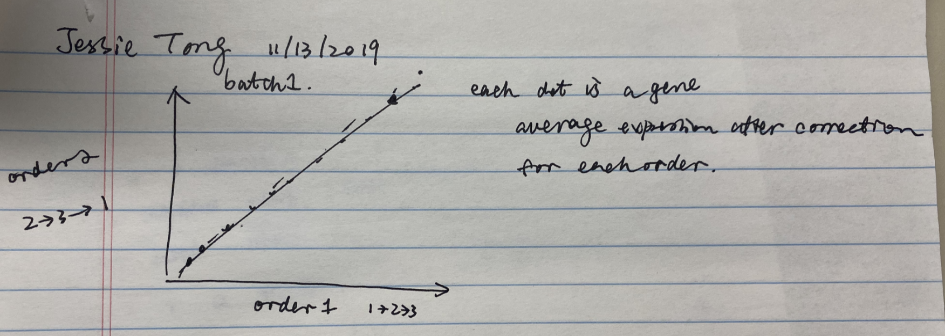

* + Check if the corrected count matrix has negative numbers (yes, do have negative values.)
  + Check if the count matrix has number larger than 5, 10
  + Perplexity values
  + Number of genes 20000
  + Create slides for presentation

**Meeting: Oct 27, 2019 (2:00 pm)**

* Revised data generation procedure

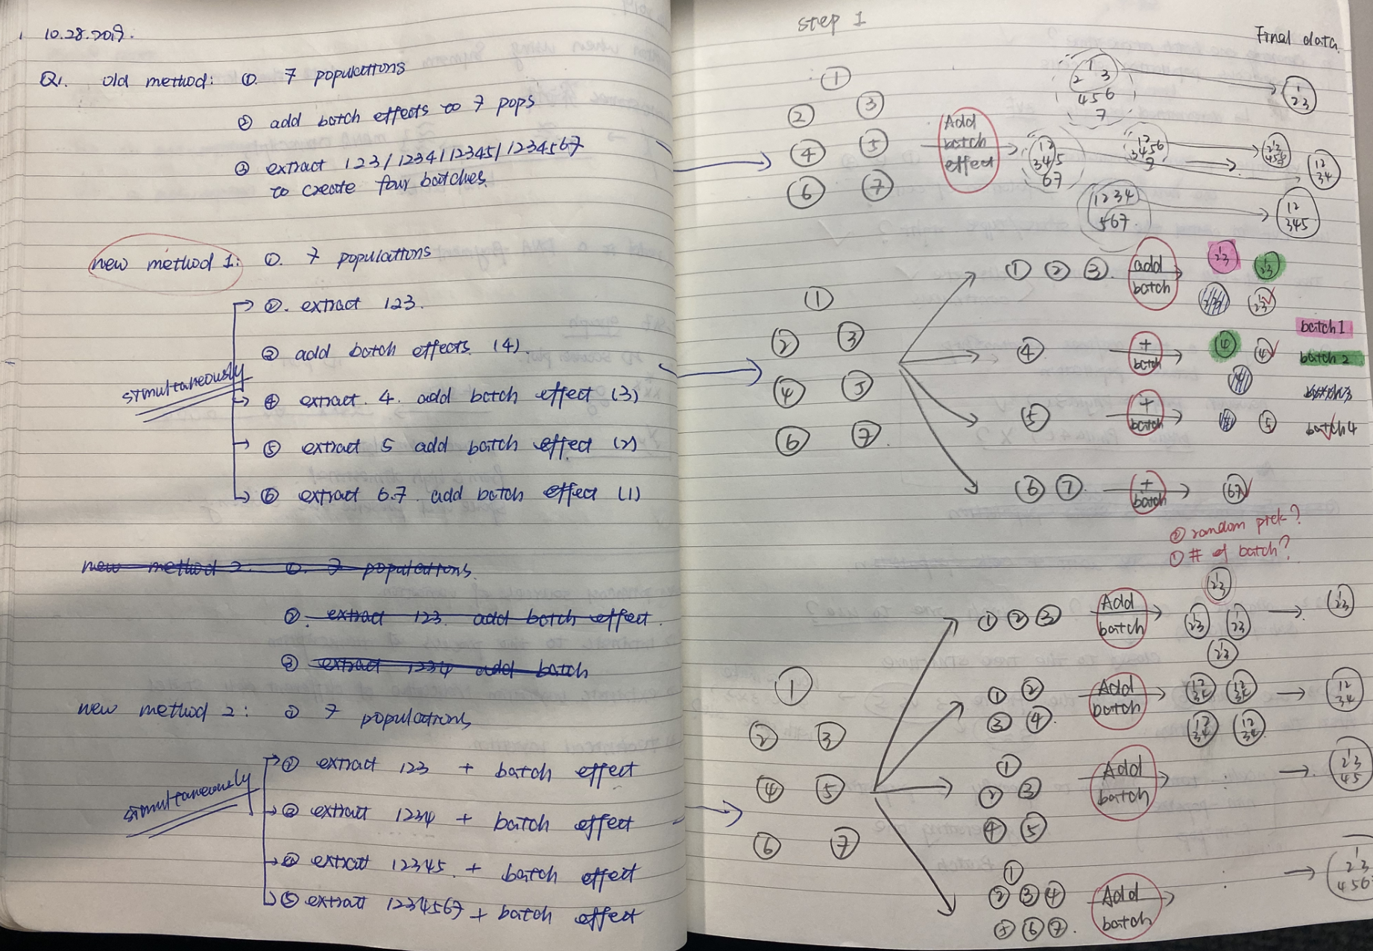

* Document:
  + simulation_1027. html
* Action plans for next week
  + Figure out how to plot the cells based on “cell type”
  + Clustering analysis (Seurat)
  + Calculate the proportion of zeros
  + Perplexity (The larger the number of cells, the larger perplexity is)
  + Reference from Prof. Li
    - “”

**Meeting: Oct 21, 2019 (10:00 am)**

* Get help from Michelle
  + Create tree with 7 populations
  + Get some parameters’ values that Michelle used
* Generation data based on batches
  + However, the way I used adds the same batch effect to the batches
* Document:
  + simulation_1020. Html
* Action plans:
  + Change the batch effect generation mechanism

**Meeting: Oct 14, 2019 (2:00 pm)**

* Playing with the Symsim packages
  + Try to understand the parameters in two main functions
* Questions:

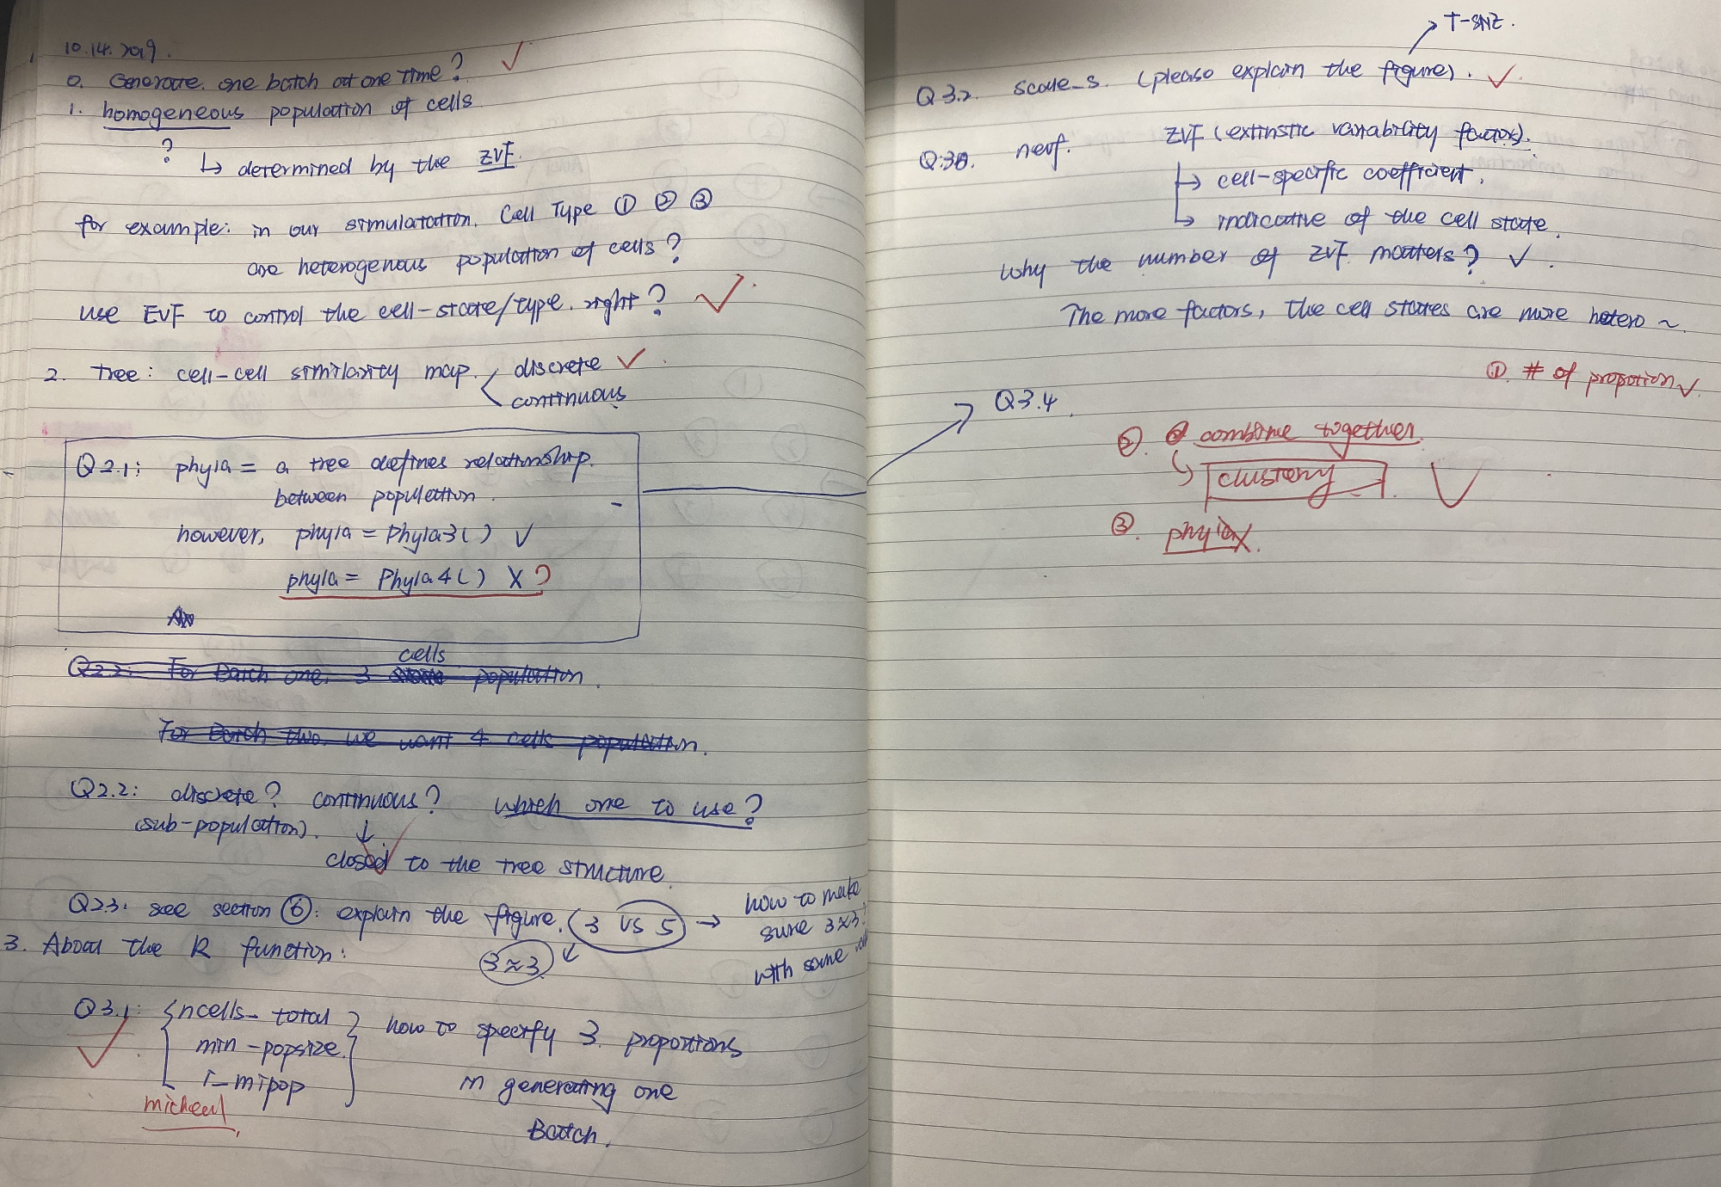

* Document:
  + simulation_1013. Html
* Action plans for next week
  + Talk with Michelle to understand the parameters

**Meeting: Oct 3, 2019 (12:00pm)**

* Additional questions about paper “Batch effects in single-cell Rna-sequencing data are corrected by matching mutual nearest neighbors”
  + The three assumptions in the paper do not have limitation or other words, these assumptions all make sense.
    - Assumption 1:
      * most of the time, the cells in different batches are from the same tissue or position. So these would be always at least one cell population presented in the batches
    - Assumption 2:
      * It is fair to say that the batch effect is orthogonal to the biological effect.
    - Assumption 3:
      * (Use figure 1 in the paper as reference)
  + Mathematics part:
    - The relationship between biological and batch effects is always additive.
* Limitation discussed about the paper:
  + The paper pair wisely compare the batches, what is the order to compare
  + Which group is regarded as the reference group to do the first batch effect comparison?
* Action plans:
  + Design simulation studies
  + Four time points as four batches
  + Each batch has 4, 5, 6, 7 cells types.

**Meeting: Sept 23, 2019 (12:30pm)**

* Questions about the following two papers:
  1. “Batch effects in single-cell Rna-sequencing data are corrected by matching mutual nearest neighbors”
  2. “bayNorm: Bayesian gene expression recovery, imputation and normalisation for single cell RNA-sequencing data”

**Meeting: Sept 13, 2019 (3:00pm)**

* Potential project
  1. Batch effect
* Read the following:
  1. “12 Grand Challenges in Single-Cell Data Science”
  2. *** “Batch effects in single-cell Rna-sequencing data are corrected by matching mutual nearest neighbors”
  3. *** “bayNorm: Bayesian gene expression recovery, imputation and normalisation for single cell RNA-sequencing data”
  4. “A test metric for assessing single-cell RNA-seq batch correction”

**Meeting: Sept 3, 2019 (3:00pm)**

* Read the following:

1. “Challenges in unsupervised clustering of single-cell RBA-seq data”
2. “Integrative single-cell analysis”

* Reading notes:
  1. “Challenges in unsupervised clustering of single-cell RBA-seq data”
     + Challenges in single-cell RNA data analysis
       - Technical
       - Computational
       - Biological
     + Important: Biological interpretation & annotation
  2. “Integrative single-cell analysis”
     + Biological terminologies to pick up
     + Relationship between DNA (which does not change in the cell) ----transcription---> RNA ----translation--> protein.